**Third Eye For The Blinds**

Team Pinmode Null

**Team Members:**

Mentor: Jannat Binta Alam

Member:

1. Mnhazul Hayat Khan
2. Fahim Abdul Kaium
3. Md. Ferdous Rahman

**Project Description:**

A hand glove that alerts the user about incoming obstacle and gives hint about obstacle’s distance.

**Components Used:**

1. Arduino
2. Sonar Sensor
3. Buzzer
4. LED
5. Breadboard
6. Resistors etc

**Circuit Diagram:**

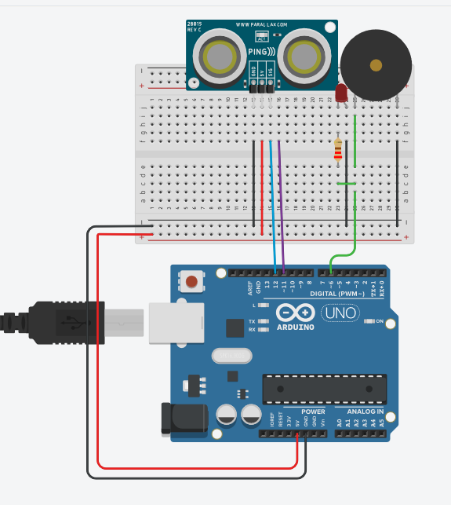

**Usage:**

The sonar will face outwards and will be attached to the palm of a person’s hand. So a blind person can point his palm to a direction in which he wants to detect obstacle and its distance. Depending on the distance of the sonar facing object the LED and the Buzzer will sound in different incremental beeps. The closer the object is the beeping will increase and the further away the object is the continuous beeping interval will decrease. The Arduino and the power supply can be mounted on the back of a person’s hand or on a backpack or even his pocket.